X Heterozygosity Gender Inference
Author: Dr. Bo Peng, MD Anderson Cancer Center and Greta Linse, Golden Helix, Inc.

Overview
From a marker mapped spreadsheet with only X-chromosome data active, this script will predict the gender of your samples by looking at X-Chromosome data.

Recommended Directory Location
Save the script to the following directory:
*..\Application Data\Golden Helix SVS\UserScripts\Spreadsheet\QualityAssurance\

Note: The Application Data folder is a hidden folder on Windows operating systems and its location varies between XP and Vista. The easiest way to locate this directory on your computer is to click on the AppData shortcut in your C:\Program Files\Golden Helix SVS\ directory. If saved to the proper folder, this script will be accessible from the spreadsheet Quality Assurance menu.

Using the Script
- Open a spreadsheet containing X-chromosome genotype data.

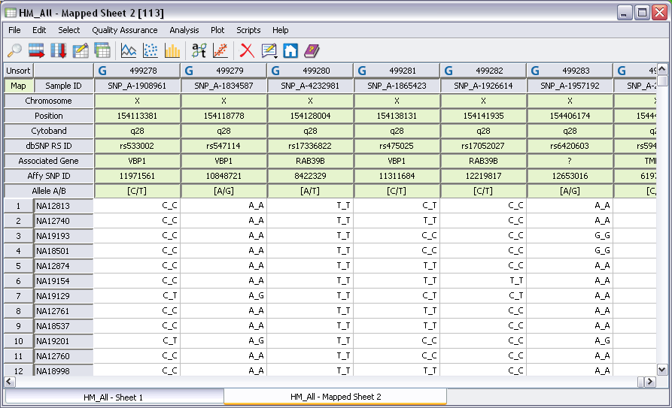

- Inactivate all other chromosomes except the X-chromosome by choosing Select >Activate by Chromosomes. Click Uncheck All and the check the X box. Click OK.
- Select Quality Assurance >Genotype Gender Check.

The result is a new spreadsheet with information about and prediction of gender for each sample. You can join this spreadsheet with a phenotype spreadsheet to see if predicted gender matches reported gender for each of your samples.

